PPG Meeting agenda
A patient participation group (PPG) is a group of people who are patients of the surgery and want to help it work as well as it can for patients, doctors and staff.
Date of meeting | Friday 23rd June 2023
Time of meeting | 12.30pm
Attendees | Kamaljeet, Sravya, Modesta, Saddia, Eduard, Cliff, Pandit, Sebastian, Edward and Shah
Apologies
Staff member taking minutes | Sravya

Social prescriber Cliff- 12.30pm- 13.00pm
Agenda Item | Discussion | Actions | Person Responsible | Date to be achieved by
Matters Arising from last meeting (date)
LGBTQ+  Presentation 12.30-12.45pm | We have been looking to involve more of the LGBTQ+ community. We have our social prescriber, Mr Cliff, here with us today.  - Eduard would like the social prescribing service to be published/advertised to patients.  - A poster is available in our reception area and in our website is available. | No action needed as the poster exists in our reception area and on our website.   | n/a | n/a
Chairperson | Congratulations! To SABA, Saddia (Mrs)- who has been elected as our chairperson. We received 3 votes in total, 2 for Saba and 1 for Nora.  Responsibilities of a chairperson:  - The Chairperson shall be elected by the PPG members to serve for a period of 24 month  Before the meeting:  It is part of the job of the Chairperson to help the PPG Admin lead to put together the Agenda for each meeting. It is a good idea for the Chairperson to:  - Make sure they know about each item to be discussed at the meeting.  - Work out how much time will be needed to cover each item on the agenda and try not to let the discussions of each item go over that time.  - Decide what result is needed from each item on the Agenda.  During the meeting:  It is an important part of the Chairperson’s role to make sure meetings run efficiently and fairly. In order to do this the Chairperson should:  - Stick to the meeting’s Agenda, so that everything that needs to be discussed at the meeting is covered and all decisions that need to be, are made.  - Always be aware of the time. Make sure the meeting stays on schedule and does not overrun its planned finishing time.  - Always aim to be open-minded, fair and impartial, never letting their own views on a subject, organization or person affect how they run the meeting.  - Liaising on behalf of the PPG with the Practice Manager  - It is the Chairperson’s role to ensure that all PPG members are enabled to undertake joint responsibility in carrying out the group’s objectives.  - Make sure everyone who wants to, has an opportunity to speak and play an equal part in any decisions made. No one person, in particular the Chairperson, should dominate the discussions.  - Keep good order and make sure everyone can hear what other people have to say.  - Helping to sort out conflicts and difference of opinion.  - Sum up any important points or discussions as they are made  - Make sure people have done things they agree to do at earlier meetings.  - Ensure that any action points of the meeting are assigned to members of the group before the meeting ends.  - Appoint a Deputy Chairperson, if the Chairperson is unable to attend the meeting. | - Role responsibilities has been sent to Saba.  - Everyone is happy to share their email addresses with Saba for further communication.  - Saba will be chairing for future meetings | Email IDs of members to be shared with Saba prior to our next meeting. | September 2023
Website | Awareness and all updates can be found on the surgery website; the website can also be translated to any language of your choice. Information on following services are also available:  - Social prescribing  - Community Pharmacy consultation service  - MSK –GetUBetter App | Members are not aware of our website in order to check for updates or the services we offer. To text all patients with our website’s link to alert of our website. A staggered text was sent out on 30/06/2023. | APM | 30/06/2023
Feedback | Last meeting we discussed, sending out feedback forms after the appointment. We have implemented a pre and post appointment text with feedback forms. Since the implementation, we have had a difference in the volume of feedbacks received. | To fill in more surveys that are sent out to patients using the link. More the feedbacks, the bigger the chance of hearing back and space for improvement. | Patients/PPG members | Ongoing
Data sharing | Members concerned of sharing personal data in reception area was taken seriously. As suggested by members, we have created a short form which is now being given to patients for their name and date of birth. The forms are then going in to our confidential waste bags. | Happy with the new system i.e. paper handed out to patients to fill in their name and date of birth | n/a | To continue
This meeting’s agenda items (date)
Well Newham  Presentation 12.45-12.55pm | Social prescriber Cliff will provide us with more information | To regularly update our websites with any future events | Sravya/Modesta | Ongoing
Patient access | - Face to face  - Telephone  - Online triage - https://florey.accurx.com/p/F84070  - Enhanced service- additional appointments on Wednesdays 3.00pm-5.30pm  - Call back – when patients is 5th in the queue will hear the option for a call back | Out of hour clinics can be contacted for appointments after 6:30 on 020 7511 8880. Personal preferences on GPs are not feasible. | n/a | n/a
Quality improvement | - Windows cleaned  - Front porch cleaned  - Alleyway cleaned | No actions required | n/a | n/a
Patient feedback | 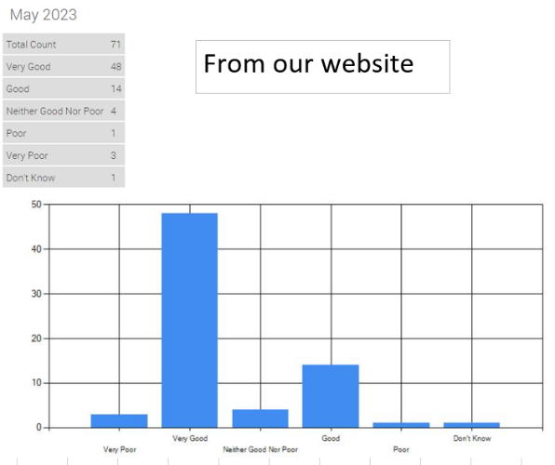  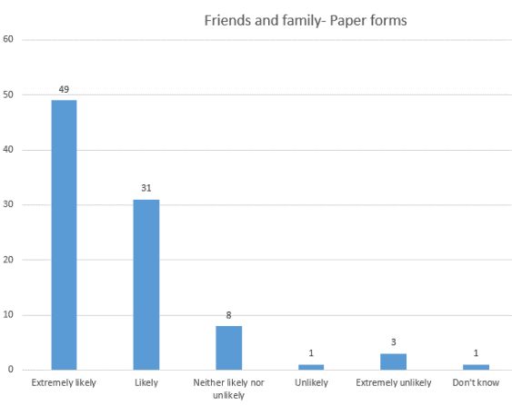  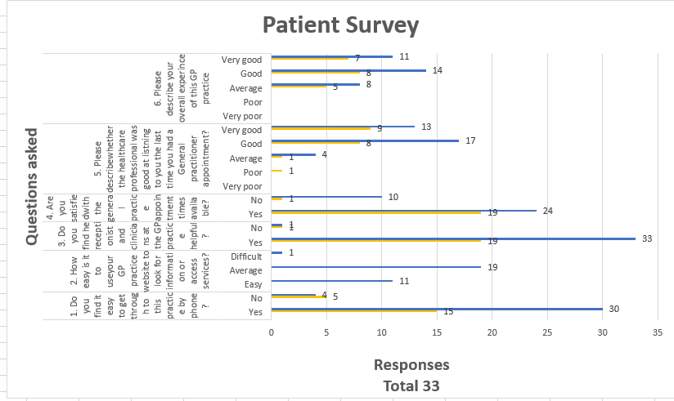 | Request to leave feedbacks with details so it can be followed up to gather more information in order to investigate. | Patients | Ongoing
Calls | Please see below  March 2023  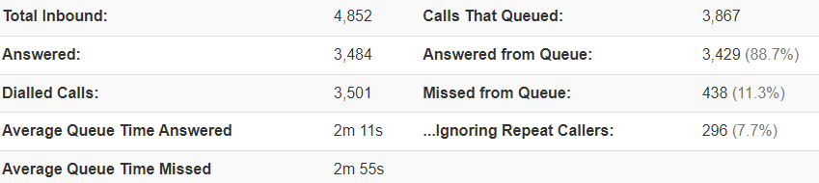  April 2023  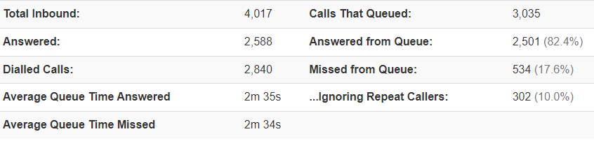  May 2023  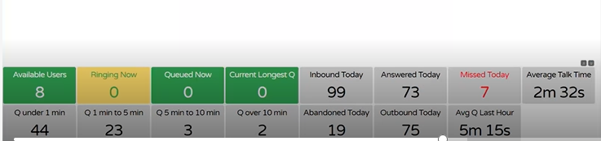 | 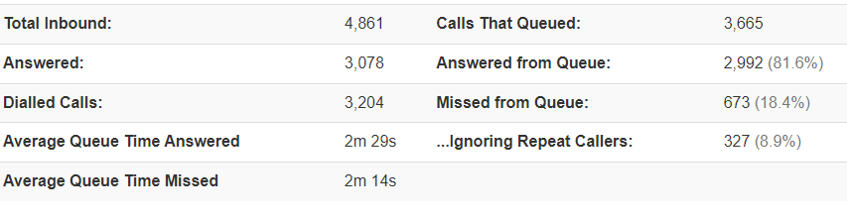
AOB | Everyone happy with progress so far. | To continue receiving constructed feedback, so improvement can be continued. | All staff | ongoing
Next meeting | September 29th 2023- Macmillan Coffee Morning | To organise everything with Saba prior to the meeting | Saba/management | 29/09/2023

